Alice Ruby, Mayor

Council Members
• Tracy Hightower (Seat A) • Chris Maines (Seat B) • Aksel Buholm (Seat C)
• Curt Armstrong (Seat D) • Andy Anderson (Seat E) • Paul Liedberg (Seat F)
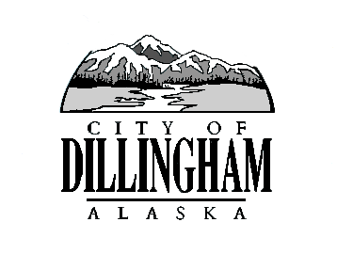
CITY OF

ALASKA
DILLINGHAM

HMAM

DILLINGHAM CITY COUNCIL

David B. Carlson Council Chambers
Dillingham City Hall, 141 Main Street, Dillingham, AK 99576 (907) 842-5212
BOE MEETING / HEARING | 5:30 P.M. | MAY 17, 2018

1. CALL TO ORDER

2. ROLL CALL

3. APPROVAL OF AGENDA page 1

4. ASSESSOR’S COMMENTS

5. DETERMINE NO. OUTSTANDING APPEALS
a. Late-Filed Appeals

- Faith Christian Community page 5

6. APPEALS FOR CONSIDERATION
a. Personal Property

- Settled Appeals

- Appeals Not Settled
- PP18-03, Farren page 11

b. Real Property

- Settled Appeals

- Appeals Not Settled (Order to be determined at meeting)
- RP18-03, Shade page 15
- RP18-17, Ayars page 23
- RP18-18, Ayars page 31
- RP18-44, Vitus Energy page 51
- RP18-45, Tennyson page 145
- RP18-59, Starflight Inc. page 153
- RP18-60, Junge page 161

7. CITIZEN DISCUSSION (Prior Notice or Agenda Items)

8. COMMITTEE COMMENTS

9. ADJOURNMENT

