|  |
| --- |
|  |
| **Council Members** |
| • Chris Napoli (Seat A) • Bill Rodawalt (Seat B) • Kaleb Westfall (Seat C) |
| • Curt Armstrong (Seat D) • Andy Anderson (Seat E) • Gregg Marxmiller (Seat F) |

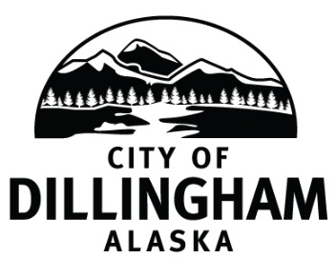

# DILLINGHAM CITY COUNCIL

***Participate by dialing 888-392-4560; meeting code 57103***

***Please MUTE your phone upon entering the call***

|  |  |  |
| --- | --- | --- |
| **SPECIAL COUNCIL MEETING** | **5:30 P.M.** | **JUNE 16, 2020** |

**1. CALL TO ORDER**

**2. ROLL CALL**

**3. APPROVAL OF AGENDA**

**4. CITIZEN’S DISCUSSION (Prior Notice or Agenda Items)**

**5. SPECIAL BUSINESS**

1. Adopt Emergency Ordinance No. 2020-16; An Emergency Ordinance of the Dillingham City Council Amending Emergency Ordinance 2020-14 to Allow Persons Required to Quarantine to Leave Dillingham Prior to Completion of the Required Quarantine if they Have Completed a COVID-19 Test in Dillingham
2. Adopt Resolution No. 2020-18; A Resolution of the Dillingham City Council Waiving the Regular Purchase Process and Utilize DMC 4.30.130 Exemptions to Purchase a New Ambulance

**6. COUNCIL COMMENTS**

**7. MAYOR’S COMMENTS**

**8. ADJOURNMENT**