|  |
| --- |
|  |
| **Council Members** |
| • Chris Napoli (Seat A) • Bill Rodawalt (Seat B) • Kaleb Westfall (Seat C) |
| • Curt Armstrong (Seat D) • Andy Anderson (Seat E) • Gregg Marxmiller (Seat F) |

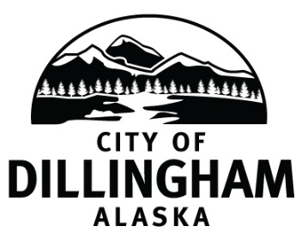

# DILLINGHAM CITY COUNCIL

***Participate by dialing 888-392-4560; meeting code 57103***

***Please MUTE your phone upon entering the call***

|  |  |  |
| --- | --- | --- |
| **WORKSHOP – COVID-19 Update**  **Ordinance 2020-07** | **6:00 P.M.** | **APRIL 30, 2020** |
| **SPECIAL COUNCIL MEETING** | **7:30 P.M.** | **APRIL 30, 2020** |

**1. CALL TO ORDER**

**2. ROLL CALL**

**3. APPROVAL OF AGENDA**

**4. CITIZEN’S DISCUSSION (Prior Notice or Agenda Items)**

**5. SPECIAL BUSINESS**

1. Adopt Emergency Ordinance No. 2020-07; An Emergency Ordinance of the Dillingham City Council; 1) Modifying and Renaming a Temporary Land Use District Formerly Called the Essential Air Travel District; 2) Establishing a Temporary Land Use District Called the Fisheries Related Use District; 3) Limiting Permitted Uses Within the Renamed Essential Travel District and Fisheries Related Use District; 4) Requiring Certain Persons to Self-Quarantine for Fourteen Days; 5) Requiring Certain Persons to Obtain a Travel Use Permit; and 6) Requiring Persons Entering the Fisheries Related Use District to Comply with State Mandates and City Rules.
2. Adopt Resolution No. 2020-14; A Resolution of the Dillingham City Council Establishing the Level of Funding for the Dillingham City School District for the Fiscal Year Ending June 30, 2021
3. Proclamation; Community Clean-up Days

**6. CITIZEN’S DISCUSSION (Open to the Public)**

**7. COUNCIL COMMENTS**

**8. MAYOR’S COMMENTS**

**9. ADJOURNMENT**