|  |
| --- |
|  |
| **Council Members** |
| • Chris Napoli (Seat A) • Bill Rodawalt (Seat B) • Kaleb Westfall (Seat C) |
| • Curt Armstrong (Seat D) • Andy Anderson (Seat E) • Gregg Marxmiller (Seat F) |

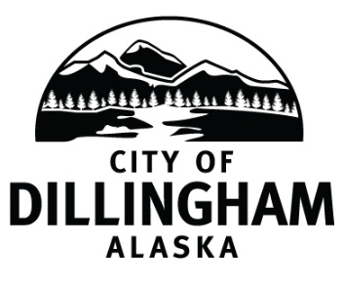

# DILLINGHAM CITY COUNCIL

Join Zoom Meeting [https://us04web.zoom.us/j/514796864](https://www.google.com/url?q=https://us04web.zoom.us/j/514796864&sa=D&ust=1584831202497000&usg=AOvVaw17xmEnU3JpbOhjBhetKyhu)

|  |  |  |
| --- | --- | --- |
| **SPECIAL COUNCIL MEETING** | **5:30 P.M.** | **MARCH 19, 2020** |

**1. CALL TO ORDER**

**2. ROLL CALL**

**3. APPROVAL OF AGENDA**

**4. SPECIAL BUSINESS**

1. City of Dillingham Operation Plan
2. Adopt Resolution No. 2020-11; A Resolution of the Dillingham City Council Declaring a Public Health Disaster Emergency
3. Adopt Resolution No. 2020-12; A Resolution of the Dillingham City Council Authorizing the City Manager to Approve Administrative Leave During the COVID-19 Epidemic Public Heath Disaster Emergency
4. Adopt Resolution No. 2020-13; A Resolution of the Dillingham City Council Approving a Grant Application and Matching Funds for a New Fire Truck

**5. CITIZEN’S DISCUSSION**

**6. COUNCIL COMMENTS**

**7. MAYOR’S COMMENTS**

**8. ADJOURNMENT**

**To Participate in the Council Meeting:**

Go to <https://www.zoom.us> and download ZOOM.

Join Zoom Meeting [https://us04web.zoom.us/j/514796864](https://www.google.com/url?q=https://us04web.zoom.us/j/514796864&sa=D&ust=1584831202497000&usg=AOvVaw17xmEnU3JpbOhjBhetKyhu)

Note: this meeting will be recorded. By logging in you consent to be included in this recording.