|  |
| --- |
| Alice Ruby, **Mayor** |
| **Council Members** |
| • Chris Napoli (Seat A) • Bill Rodawalt (Seat B) • Aksel Buholm (Seat C) |
| • Curt Armstrong (Seat D) • Andy Anderson (Seat E) • Gregg Marxmiller (Seat F) |

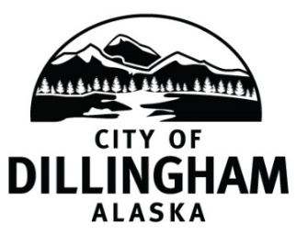

# DILLINGHAM CITY COUNCIL

David B. Carlson Council Chambers

Dillingham City Hall, 141 Main Street, Dillingham, AK 99576 (907) 842-5212

|  |  |  |
| --- | --- | --- |
| **SPECIAL MEETING** | **5:30 P.M.** | **OCTOBER 25, 2019** |

**1. CALL TO ORDER**

**2. ROLL CALL**

**3. APPROVAL OF AGENDA**

**4. SPECIAL BUSINESS**

a. FY2018 Audit Presentation

b. Adopt Resolution No2019-20; A Resolution of the Dillingham City Council Accepting the Year End Audit for the Fiscal Year Ending June 30, 2018

c. Adopt Resolution No. 2019-33; A Resolution of the Dillingham City Council Waiving the Purchase Restrictions and Awarding a Contract to Bennett Enterprises, LLC to Remove Debris from the Bingman Property

**5. CITIZEN’S DISCUSSION (Open to the Public)**

**6. COUNCIL COMMENTS**

**7. MAYOR’S COMMENTS**

**8. ADJOURNMENT**