|  |
| --- |
| Alice Ruby, **Mayor** |
| **Council Members** |
| • Chris Napoli (Seat A) • Chris Maines (Seat B) • Aksel Buholm (Seat C) |
| • Curt Armstrong (Seat D) • Andy Anderson (Seat E) • Gregg Marxmiller (Seat F) |

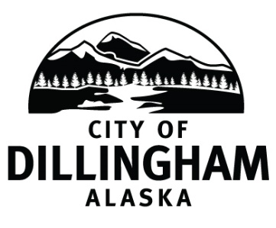

# DILLINGHAM CITY COUNCIL

David B. Carlson Council Chambers

Dillingham City Hall, 141 Main Street, Dillingham, AK 99576 (907) 842-5212

|  |  |  |
| --- | --- | --- |
| **REGULAR MEETING** | **7:00 P.M.** | **SEPTEMBER 9, 2019** |

**1. CALL TO ORDER**

**2. ROLL CALL**

**3. APPROVAL OF MINUTES**

1. Regular Council Meeting, August 1, 2019 page 3

**4. APPROVAL OF CONSENT AGENDA**

**APPROVAL OF AGENDA**

**5. SPECIAL BUSINESS**

a. Oath of Office – Trevor Farnsworth, Patrol Officer

**6. STAFF REPORTS**

1. City Manager and Staff Reports page 9
2. Standing Committee Reports page 57

**7. PUBLIC HEARINGS**

**8. CITIZEN’S DISCUSSION (Prior Notice or Agenda Items)**

**9. ORDINANCES AND RESOLUTIONS**

1. Adopt Resolution No. 2019-26; A Resolution of the Dillingham City Council Accepting the Resignation of Chris Maines and Offer Thanks and Commendation for his Service on the Dillingham City Council page 59
2. Adopt Resolution No. 2019-27; A Resolution of the Dillingham City Council Authorizing the City of Dillingham to Accept a Loan from the Alaska Department of Environmental Conservation Alaska Drinking Water Fund for Improvements to Community Water Infrastructure page 63
3. Adopt Resolution No. 2019-28; A Resolution of the Dillingham City Council Supporting Curyung Tribal Council’s BBEDC Arctic Tern Grant Application for Hosting a Phlight Club Event

**10. UNFINISHED BUSINESS**

1. Citizen Committee Appointments
2. Senior Advisory Commission – 1 seat (no letters of interest received)
3. Library Advisory Board – 2 seats, two letters of interest page 65
4. Progress Report

1) Dave Carlson House Property

2) Territorial School

**11. NEW BUSINESS**

1. Approve Action Memorandum 2019-06; Award a Contract for the FY20 Aggregate Bid page 67
2. Approve Action Memorandum 2019-09; Award a Contract for ITB 2019-05, Dillingham Streets Rehabilitation page 71
3. Approve Action Memorandum 2019-10; Award a Contract for ITB 2019-07, Water System Improvements page 75

**12. CITIZEN’S DISCUSSION (Open to the Public)**

**13. COUNCIL COMMENTS**

**14. MAYOR’S COMMENTS**

**15. EXECUTIVE SESSION**

1. Personnel Issue – City Manager Evaluation

**16. ADJOURNMENT**