|  |
| --- |
| Alice Ruby, **Mayor** |
| **Council Members** |
| • Chris Napoli (Seat A) • Chris Maines (Seat B) • Aksel Buholm (Seat C) |
| • Curt Armstrong (Seat D) • Andy Anderson (Seat E) • Gregg Marxmiller (Seat F) |

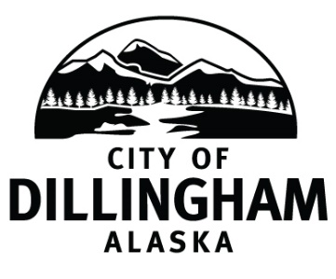

# DILLINGHAM CITY COUNCIL

David B. Carlson Council Chambers

Dillingham City Hall, 141 Main Street, Dillingham, AK 99576 (907) 842-5212

|  |  |  |
| --- | --- | --- |
| **REGULAR MEETING** | **7:00 P.M.** | **MAY 8, 2019** |

**1. CALL TO ORDER**

**2. ROLL CALL**

**3. APPROVAL OF MINUTES**

1. Regular Council Meeting, April 4, 2019 page 3
2. Special Council Meeting, April 11, 2019 page 7
3. Special Council Meeting, April 15, 2019 page 9

**4. APPROVAL OF CONSENT AGENDA**

**APPROVAL OF AGENDA**

**5. STAFF REPORTS**

1. City Manager and Staff Reports page 11
2. Standing Committee Reports

**6. PUBLIC HEARINGS**

**7. CITIZEN’S DISCUSSION (Prior Notice or Agenda Items)**

**8. ORDINANCES AND RESOLUTIONS**

a. Approve Resolution 2019-14; A Resolution of the Dillingham City Council Declaring the Eligibility of the City of Dillingham to Submit an Application to the Alaska Department of Transportation and Public Facilities (ADOT&PF) for the Community Transportation Program for the Nerka Subdivision Roadway Improvements Project in Dillingham, Alaska and Authorizing Curyung Tribal Council to Sign the Application and Future Project Agreements page 39

**9. UNFINISHED BUSINESS**

1. Citizen Committee Appointments
2. Senior Advisory Commission – 1 seat open
3. Friends of the Landfill – 2 seats open (*four letters of interest*) page 41
4. Progress Report

1) Dave Carlson House Property

2) Territorial School

**10. NEW BUSINESS**

1. City Staffing

**11. CITIZEN’S DISCUSSION (Open to the Public)**

**12. COUNCIL COMMENTS**

**13. MAYOR’S COMMENTS**

**14. ADJOURNMENT**