|  |
| --- |
|  |
| **Council Members** |
| • Chris Napoli (Seat A) • Chris Maines (Seat B) • Aksel Buholm (Seat C) |
| • Curt Armstrong (Seat D) • Andy Anderson (Seat E) • Gregg Marxmiller (Seat F) |

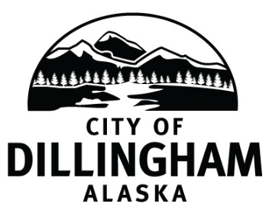

# DILLINGHAM CITY COUNCIL

David B. Carlson Council Chambers

Dillingham City Hall, 141 Main Street, Dillingham, AK 99576 (907) 842-5212

|  |  |  |
| --- | --- | --- |
| **WORKSHOP – GO Bond** | **5:30 P.M.** | **APRIL 11, 2019** |
| **SPECIAL COUNCIL MEETING** | **6:00 P.M.** | **APRIL 11, 2019** |

**1. CALL TO ORDER**

**2. ROLL CALL**

**3. APPROVAL OF AGENDA**

**4. CITIZEN’S DISCUSSION (Prior Notice or Agenda Items)**

**5. SPECIAL BUSINESS**

1. Adopt Resolution No. 2019-12; A Resolution of the Dillingham City Council Establishing the Level of Funding for the Dillingham City School District for the Fiscal Year Ending June 30, 2020
2. Consider General Obligation Bond

**6. CITIZEN’S DISCUSSION (Open to the Public)**

**7. COUNCIL COMMENTS**

**8. MAYOR’S COMMENTS**

**9. ADJOURNMENT**