|  |
| --- |
| Alice Ruby, **Mayor** |
| **Council Members** |
| • Chris Napoli (Seat A) • Chris Maines (Seat B) • Aksel Buholm (Seat C) |
| • Curt Armstrong (Seat D) • Andy Anderson (Seat E) • Gregg Marxmiller (Seat F) |

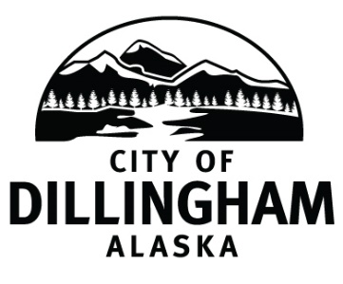

# DILLINGHAM CITY COUNCIL

David B. Carlson Council Chambers

Dillingham City Hall, 141 Main Street, Dillingham, AK 99576 (907) 842-5212

|  |  |  |
| --- | --- | --- |
| **WORKSHOP**  **Council Training** | **5:30 P.M.** | **APRIL 4, 2019** |
| **WORKSHOP – GO Bond** | **7:00 P.M** | **APRIL 4, 2019** |
| **REGULAR MEETING** | **7:30 P.M.** | **APRIL 4, 2019** |

**1. CALL TO ORDER**

**2. ROLL CALL**

**3. APPROVAL OF MINUTES**

1. Regular Council Meeting, March 7, 2019 page 5

**4. APPROVAL OF CONSENT AGENDA**

**APPROVAL OF AGENDA**

**5. STAFF REPORTS**

1. City Manager and Staff Reports page 9
2. Standing Committee Reports page 29

**6. PUBLIC HEARINGS**

**7. CITIZEN’S DISCUSSION (Prior Notice or Agenda Items)**

**8. ORDINANCES AND RESOLUTIONS**

a. Adopt Resolution 2019-10, A Resolution of the Dillingham City Council Accepting the Certification of the Canvassing Committee Results and Certifying the March 26, 2019 Special City Election page 41

b. Adopt Resolution 2019-11, A Resolution of the Dillingham City Council Authorizing the City Manager to Request Competitive Bids for Cleanup of the Bingman Property Area at the Harbor page 47

**9. UNFINISHED BUSINESS**

1. Citizen Committee Appointments
2. Senior Advisory Commission – 1 seat open
3. Friends of the Landfill – 2 seats open (*four letters of interest*) page 51
4. Progress Report

1) Dave Carlson House Property

2) Territorial School

**10. NEW BUSINESS**

a. Schedule a Board of Equalization Meeting May 16, at 5:30 PM

1. Schedule Special Meeting to Adopt the Dillingham City School District Budget Appropriation
2. Approve Action Memorandum 2019-04, Authorize the City Manager to Collaborate with Nushagak Cooperative for a Community Clean Up, May 3, 4, and 5 page 55
3. General Obligation Bond Discussion

**11. CITIZEN’S DISCUSSION (Open to the Public)**

**12. COUNCIL COMMENTS**

**13. MAYOR’S COMMENTS**

**14. ADJOURNMENT**