|  |
| --- |
| Alice Ruby, **Mayor** |
| **Council Members** |
| • Chris Napoli (Seat A) • Chris Maines (Seat B) • Aksel Buholm (Seat C) |
| • Curt Armstrong (Seat D) • Andy Anderson (Seat E) • Gregg Marxmiller (Seat F) |

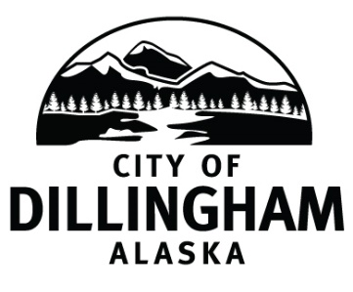

# DILLINGHAM CITY COUNCIL

David B. Carlson Council Chambers

Dillingham City Hall, 141 Main Street, Dillingham, AK 99576 (907) 842-5212

|  |  |  |
| --- | --- | --- |
| **WORKSHOP**  **Financial Statement Review** | **6:30 P.M.** | **MARCH 7, 2019** |
| **REGULAR MEETING** | **7:00 P.M.** | **MARCH 7, 2019** |

**1. CALL TO ORDER**

**2. ROLL CALL**

**3. APPROVAL OF MINUTES**

1. Regular Council Meeting, February 7, 2019 page 3

**4. APPROVAL OF CONSENT AGENDA**

**APPROVAL OF AGENDA**

**5. STAFF REPORTS**

1. City Manager and Staff Reports page 7
2. Standing Committee Reports

**6. PUBLIC HEARINGS**

**7. CITIZEN’S DISCUSSION (Prior Notice or Agenda Items)**

**8. ORDINANCES AND RESOLUTIONS**

a. Adopt Resolution 2019-08; A Resolution of the Dillingham City Council Authorizing the City Manager to Award the Landfill Groundwater Monitoring Wells Construction Contract page 25

1. Adopt Resolution 2019-09; A Resolution of the Dillingham City Council in Support of Nushagak Electric & Telephone Cooperative’s (NETC) Continuing Study and Evaluation Efforts for Development of a Hydroelectric Facility on the Nuyakuk River and Support for the Legislation to Allow Access to Wood Tikchik State Park (WTSP) for This Effort

**9. UNFINISHED BUSINESS**

1. Citizen Committee Appointments
2. Senior Advisory Commission – 1 seat open
3. Friends of the Landfill – 11 seats open (*eight letters of interest*) page 49
4. General Obligation Bond Update
5. Progress Report

1) Dave Carlson House Property

2) Territorial School

**10. NEW BUSINESS**

a. Approve Action Memorandum 2019-01; Award a one year contract for Engineering Services to CRW Engineering Group, LLC, Anchorage AK page 57

1. Approve Action Memorandum 2019-02; Authorize the City Manager to Enter into an Agreement with Bristol Engineering Services Company LLC (BESC) for the Oversight of the Landfill Groundwater Monitoring Wells Construction Project and Well Sampling
2. Approve Action Memorandum 2019-03; Authorize the City Manager to Purchase a Top Handler

**11. CITIZEN’S DISCUSSION (Open to the Public)**

**12. COUNCIL COMMENTS**

**13. MAYOR’S COMMENTS**

**14. ADJOURNMENT**