|  |
| --- |
| Alice Ruby, **Mayor** |
| **Council Members** |
| • Chris Napoli (Seat A) • Chris Maines (Seat B) • Aksel Buholm (Seat C) |
| • Curt Armstrong (Seat D) • Andy Anderson (Seat E) • Gregg Marxmiller (Seat F) |

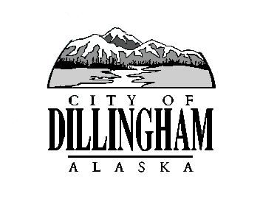

CITY OF

ALASKA

DILLINGHAM

**HMAM**

# DILLINGHAM CITY COUNCIL

David B. Carlson Council Chambers

Dillingham City Hall, 141 Main Street, Dillingham, AK 99576 (907) 842-5212

|  |  |  |
| --- | --- | --- |
| **WORKSHOP – SEWARD STREET AND D STREET REHAB SCOPING** | **6:00 P.M.** | **DECEMBER 6, 2018** |
| **REGULAR MEETING** | **7:00 P.M.** | **DECEMBER 6, 2018** |

**1. CALL TO ORDER**

**2. ROLL CALL**

**3. APPROVAL OF MINUTES**

1. Regular Council Meeting, November 1, 2018 page 3

**4. APPROVAL OF CONSENT AGENDA**

**APPROVAL OF AGENDA**

**5. STAFF REPORTS**

1. City Manager and Staff Reports page 7
2. Standing Committee Reports page 43

**6. PUBLIC HEARINGS**

**7. CITIZEN’S DISCUSSION (Prior Notice or Agenda Items)**

**8. ORDINANCES AND RESOLUTIONS**

a. Introduce Ordinance 2018-07, An Ordinance of the Dillingham City Council Amending Title 7, Animals, by Adding Classification and Regulation to Section 7.40 Care and Control of Animals page 47

1. Introduce Ordinance 2018-08; An Ordinance of the Dillingham City Council Amending Dillingham Municipal Code Chapter 15.08, Updating the Adoption of Building Codes page 65

**9. UNFINISHED BUSINESS**

1. Citizen Committee Appointments
2. Progress Report

1) Dave Carlson House Property

2) Territorial School

**10. NEW BUSINESS**

a. Approve Action Memorandum 2018-11, Authorize City Manager to enter into a new contract with Premera Blue Cross Blue Shield of Alaska and Navia for an HRA page 67

b. GO Bond Strategy for Seward Street and D Street Rehabilitation Project

1. Schedule Special Council Meeting December 20, 2018

**11. CITIZEN’S DISCUSSION (Open to the Public)**

**12. COUNCIL COMMENTS**

**13. MAYOR’S COMMENTS**

**14. ADJOURNMENT**