|  |
| --- |
| Alice Ruby, **Mayor** |
| **Council Members** |
| • Chris Napoli (Seat A) • Chris Maines (Seat B) • Aksel Buholm (Seat C) |
| • Curt Armstrong (Seat D) • Andy Anderson (Seat E) • Gregg Marxmiller (Seat F) |

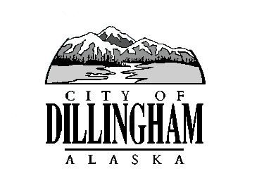

CITY OF

ALASKA

DILLINGHAM

**HMAM**

# DILLINGHAM CITY COUNCIL

David B. Carlson Council Chambers

Dillingham City Hall, 141 Main Street, Dillingham, AK 99576 (907) 842-5212

|  |  |  |
| --- | --- | --- |
| **REGULAR MEETING** | **7:00 P.M.** | **NOVEMBER 1, 2018** |

**1. CALL TO ORDER**

**2. ROLL CALL**

**3. APPROVAL OF MINUTES**

1. Regular Council Meeting, October 4, 2018 page 3
2. Special Council Meeting, October 11, 2018 page 9

**4. APPROVAL OF CONSENT AGENDA**

a. Approve Resolution 2018-21, A Resolution of the Dillingham City Council Amending the Investment Account Signature Authority Forms for City Investment Accounts Due to a Change in Council Members and Personnel page 11

b. Approve Resolution 2018-22, A Resolution of the Dillingham City Council Amending the Bank Signature Card for Wells Fargo Checking Account Due to a Change in Council Members page 13

**APPROVAL OF AGENDA**

**5. STAFF REPORTS**

1. City Manager and Staff Reports page 15
2. Standing Committee Reports

**6. PUBLIC HEARINGS**

a. Willow Tree Inn Liquor License Transfer

**7. CITIZEN’S DISCUSSION (Prior Notice or Agenda Items)**

**8. ORDINANCES AND RESOLUTIONS**

a. Approve Resolution 2018-23; A Resolution of the Dillingham City Council Supporting Resolution No. 2018-01 From the Alaska Association of Harbormasters and Port Administrators in Support of Full Funding ($7,409,439) for the State of Alaska Municipal Harbor Facility Grant Program in the FY2020 State Capital Budget page 47

**9. UNFINISHED BUSINESS**

1. Citizen Committee Appointments
2. Library Advisory Board, 1 Seat Open (*no letter of interest*)
3. Progress Report

1) Dave Carlson House Property

2) Territorial School

**10. NEW BUSINESS**

a. Approve Action Memorandum 2018-10, Authorize Administrative Leave for Christmas and New Year’s Holiday page 53

1. Willow Tree Inn Liquor License Transfer page 55
2. Olsen’s Liquor Store Liquor License Renewal page 73
3. Standing Committee Appointments

**11. CITIZEN’S DISCUSSION (Open to the Public)**

**12. COUNCIL COMMENTS**

**13. MAYOR’S COMMENTS**

**14. EXECUTIVE SESSION**

1. Legal Update – Backford v City of Dillingham
2. Personnel Issue – City Manager Evaluation

**15. ADJOURNMENT**