|  |
| --- |
| Alice Ruby, **Mayor** |
| **Council Members** |
| • Chris Napoli (Seat A) • Chris Maines (Seat B) • Aksel Buholm (Seat C) |
| • Curt Armstrong (Seat D) • Andy Anderson (Seat E) • Paul Liedberg (Seat F) |

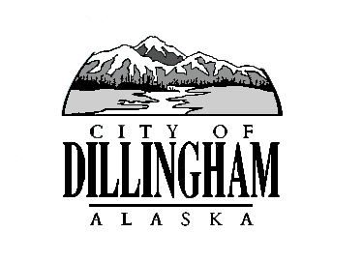

CITY OF

ALASKA

DILLINGHAM

**HMAM**

# DILLINGHAM CITY COUNCIL

David B. Carlson Council Chambers

Dillingham City Hall, 141 Main Street, Dillingham, AK 99576 (907) 842-5212

|  |  |  |  |  |
| --- | --- | --- | --- | --- |
| **SPECIAL MEETING** | | **7:00 P.M.** | **OCTOBER 11, 2018** | |
| **WORKSHOP – CIP PROJECT FUNDING AND TIMING** | **FOLLOWING MEETING** | | | **OCTOBER 11, 2018** |

**1. CALL TO ORDER**

**2. ROLL CALL**

**3. APPROVAL OF AGENDA**

**4. SPECIAL BUSINESS**

a. Adopt Resolution 2018-19; A Resolution of the Dillingham City Council Approving a Grant Application and Matching Funds for a New Fire Engine

b. Adopt Resolution No. 2018-20, A Resolution of the Dillingham City Council Accepting the Certification of the Canvassing Committee Results and Certifying the October 2, 2018 Regular City Election

*DMC 3.7.040 B, Upon certification of a valid election, the city council shall direct the clerk to deliver to each person elected to office a “certificate of election” signed by the mayor and the clerk and authenticated by the seal of the city.*

c. Oath of Office for Newly Elected Council Members, Mayor, and School Board Members

**5. CITIZEN’S DISCUSSION (Open to the Public)**

**6. COUNCIL COMMENTS**

**7. MAYOR’S COMMENTS**

**8. ADJOURNMENT**