|  |
| --- |
| Alice Ruby, **Mayor** |
| **Council Members** |
| • Chris Napoli (Seat A) • Chris Maines (Seat B) • Aksel Buholm (Seat C) |
| • Curt Armstrong (Seat D) • Andy Anderson (Seat E) • Paul Liedberg (Seat F) |

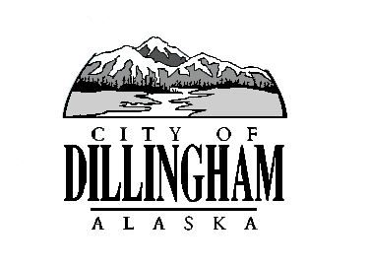

CITY OF

ALASKA

DILLINGHAM

**HMAM**

# DILLINGHAM CITY COUNCIL

David B. Carlson Council Chambers

Dillingham City Hall, 141 Main Street, Dillingham, AK 99576 (907) 842-5212

|  |  |  |
| --- | --- | --- |
| **SPECIAL MEETING** | **5:00 P.M.** | **SEPTEMBER 24, 2018** |

**1. CALL TO ORDER**

**2. ROLL CALL**

**3. APPROVAL OF AGENDA**

**4. SPECIAL BUSINESS**

1. Action Memorandum 2018-08, Authorize the City Manager to Award a Contract for RFP 2018-04, Furnish Petroleum & Propane Fuel
2. Action Memorandum 2018-09, Authorize the City Manager to Award a contract to PND for RFP 2018-05, D and Seward Street Rehabilitation, Geotechnical; RFP 2018-06, D and Seward Street Rehabilitation, Survey; and RFP 2018-07, D and Seward Street Rehabilitation, Design

**5. CITIZEN’S DISCUSSION (Open to the Public)**

**6. COUNCIL COMMENTS**

**7. MAYOR’S COMMENTS**

**8. ADJOURNMENT**