|  |
| --- |
| Alice Ruby, **Mayor** |
| **Council Members** |
| • Chris Napoli (Seat A) • Chris Maines (Seat B) • Aksel Buholm (Seat C) |
| • Curt Armstrong (Seat D) • Andy Anderson (Seat E) • Paul Liedberg (Seat F) |

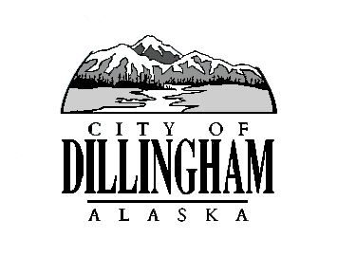

CITY OF

ALASKA

DILLINGHAM

**HMAM**

# DILLINGHAM CITY COUNCIL

David B. Carlson Council Chambers

Dillingham City Hall, 141 Main Street, Dillingham, AK 99576 (907) 842-5212

|  |  |  |
| --- | --- | --- |
| **WORKSHOP, REVENUE IDEAS FOR CIP FUNDING** | **6:00 P.M.** | **SEPTEMBER 6, 2018** |
| **REGULAR MEETING** | **7:00 P.M.** | **SEPTEMBER 6, 2018** |

**1. CALL TO ORDER**

**2. ROLL CALL**

**3. APPROVAL OF MINUTES**

1. Regular Council Meeting, August 2, 2018
2. Board of Equalization Meeting, August 16, 2018
3. Special Council Meeting, August 27, 2018

**4. APPROVAL OF CONSENT AGENDA**

**APPROVAL OF AGENDA**

**5. STAFF REPORTS**

1. City Manager and Staff Reports
2. Standing Committee Reports

**6. PUBLIC HEARINGS**

**7. CITIZEN’S DISCUSSION (Prior Notice or Agenda Items)**

a. Corey Evans, President Dillingham City School District, and Jason Johnson, Dillingham City School District Superintendent

**8. ORDINANCES AND RESOLUTIONS**

a. Ordinance 2018-05. An Ordinance of the Dillingham City Council Amending Section 4.16.020 Business License, to Add an Exemption for Casual and Isolated Sales

1. Ordinance 2018-06, An Ordinance of the Dillingham City Council Amending Dillingham Municipal Code Chapter 4.15.030, Exemptions Renewing the Taxable Amount for Fishing Vessels and Aircraft
2. Resolution 2018-14, A Resolution of the Dillingham City Council Authorizing Foreclosure Proceedings on Delinquent Property Taxes for the Years 2012-2017
3. Resolution 2018-15, A Resolution of the Dillingham City Council Awarding the Contract for the Fire Suppression Work at the Department of Public Safety
4. Resolution 2018-16, A Resolution of the Dillingham City Council Authorizing the City Manager to Waive the Competitive Bid Process and Approve Emergency Road Repairs

**9. UNFINISHED BUSINESS**

1. Citizen Committee Appointments
2. Senior Advisory Commission, 1 Seat Open – *(one letter of interest)*
3. Library Advisory Board, 1 Seat Open
4. Progress Report

1) Dave Carlson House Property

2) Territorial School

**10. NEW BUSINESS**

a. City Manager Evaluation

**11. CITIZEN’S DISCUSSION (Open to the Public)**

**12. COUNCIL COMMENTS**

**13. MAYOR’S COMMENTS**

**14. ADJOURNMENT**