|  |
| --- |
| Alice Ruby, **Mayor** |
| **Council Members** |
| • Chris Napoli (Seat A) • Chris Maines (Seat B) • Aksel Buholm (Seat C) |
| • Curt Armstrong (Seat D) • Andy Anderson (Seat E) • Paul Liedberg (Seat F) |

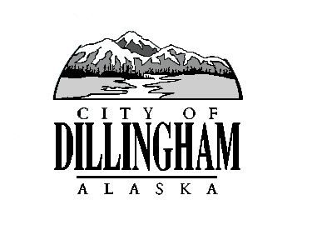

CITY OF

ALASKA

DILLINGHAM

**HMAM**

# DILLINGHAM CITY COUNCIL

David B. Carlson Council Chambers

Dillingham City Hall, 141 Main Street, Dillingham, AK 99576 (907) 842-5212

|  |  |  |  |
| --- | --- | --- | --- |
| **REGULAR MEETING** |  | **7:00 P.M.** | **AUGUST 2, 2018** |

**1. CALL TO ORDER**

**2. ROLL CALL**

**3. APPROVAL OF MINUTES**

1. Regular Council Meeting, June 21, 2018
2. Special Council Meeting, July 16, 2018

**4. APPROVAL OF CONSENT AGENDA**

**APPROVAL OF AGENDA**

**5. STAFF REPORTS**

1. City Manager and Staff Reports
2. Standing Committee Reports

**6. PUBLIC HEARINGS**

**7. CITIZEN’S DISCUSSION (Prior Notice or Agenda Items)**

a. Daniel Cheyette, Bristol Alliance Fuels

1. Jack Smith, Dillingham Waste Management LLC

**8. ORDINANCES AND RESOLUTIONS**

a. Resolution 2018-12. A Resolution of the Dillingham City Council Authorizing the City Manager to Award an Engineering Contract for the Design Phase of the Wastewater System Upgrades and Landfill Groundwater Monitoring Wells

**9. UNFINISHED BUSINESS**

1. Citizen Committee Appointments
2. Senior Advisory Commission, 1 Seat Open
3. Library Advisory Board, 1 Seat Open
4. Planning Commission, 1 Seat Open – (*one letter of interest*)
5. Progress Report

1) Dave Carlson House Property

2) Territorial School

**10. NEW BUSINESS**

1. Action Memorandum 2018-06, Award Contract for the FY19 Aggregate Bid
2. Action Memorandum 2018-07, Approve Contract with the State of Alaska Department of Corrections for the Regional and Community Jail FY19
3. Review Protest of Willow Tree Liquor License
4. Discussion Relating to Additional and/or New Revenue Stream for CIP Projects

**11. CITIZEN’S DISCUSSION (Open to the Public)**

**12. COUNCIL COMMENTS**

**13. MAYOR’S COMMENTS**

**14. ADJOURNMENT**