|  |
| --- |
| Alice Ruby, **Mayor** |
| **Council Members** |
| • Chris Napoli (Seat A) • Chris Maines (Seat B) • Aksel Buholm (Seat C) |
| • Curt Armstrong (Seat D) • Andy Anderson (Seat E) • Paul Liedberg (Seat F) |

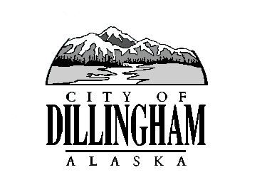

CITY OF

ALASKA

DILLINGHAM

**HMAM**

# DILLINGHAM CITY COUNCIL

David B. Carlson Council Chambers

Dillingham City Hall, 141 Main Street, Dillingham, AK 99576 (907) 842-5212

|  |  |  |  |
| --- | --- | --- | --- |
| **SPECIAL MEETING** |  | **12:15 P.M.** | **JULY 16, 2018** |

**1. CALL TO ORDER**

**2. ROLL CALL**

**3. APPROVAL OF AGENDA**

**4. SPECIAL BUSINESS**

a. Adopt Resolution 2018-11, A Resolution of the Dillingham City Council Approving Engineering Design Funds for CIP Projects

b. Executive Session – Legal Matters

1. Annexation Petition Appeal
2. Backford vs. City of Dillingham

**5. CITIZEN’S DISCUSSION (Open to the Public)**

**6. COUNCIL COMMENTS**

**7. MAYOR’S COMMENTS**

**8. ADJOURNMENT**

### ***City Clerk Note:***

### **DMC 2.09.020 Special meetings.**

B.  Advance oral or written notice of at least twenty-four hours preceding a special meeting shall be given each council member. The notice shall specify the time, place and subject matter of the meeting. No business shall be transacted at the meeting that is not mentioned in the notice. Notice shall be served personally on each member of the council or left at the member’s usual place of business or residence by the city clerk or the clerk’s designee.