|  |
| --- |
| Alice Ruby, **Mayor** |
| **Council Members** |
| • Tracy Hightower (Seat A) • Chris Maines (Seat B) • Aksel Buholm (Seat C) |
| • Curt Armstrong (Seat D) • Andy Anderson (Seat E) • Paul Liedberg (Seat F) |

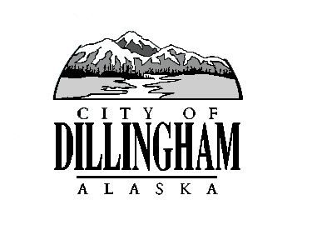

CITY OF

ALASKA

DILLINGHAM

**HMAM**

# DILLINGHAM CITY COUNCIL

David B. Carlson Council Chambers

Dillingham City Hall, 141 Main Street, Dillingham, AK 99576 (907) 842-5212

|  |  |  |  |
| --- | --- | --- | --- |
| **REGULAR MEETING** |  | **7:00 P.M.** | **JUNE 21, 2018** |

**1. CALL TO ORDER**

**2. ROLL CALL**

**3. APPROVAL OF MINUTES**

1. Regular Council Meeting, June 7, 2018 page 3

**4. APPROVAL OF CONSENT AGENDA**

1. Adopt Resolution No. 2018-09, A Resolution of the Dillingham City Council to Offer Thanks and Commendation to Tracy Hightower For His Service on the Dillingham City Council page 9

**APPROVAL OF AGENDA**

**5. STAFF REPORTS**

**6. PUBLIC HEARINGS**

**7. CITIZEN’S DISCUSSION (Prior Notice or Agenda Items)**

**8. ORDINANCES AND RESOLUTIONS**

1. Adopt Resolution No. 2018-10, A Resolution of the Dillingham City Council Formally Adopting the 2018 City of Dillingham Emergency Operations Plan page 11

**9. UNFINISHED BUSINESS**

1. Citizen Committee Appointments
2. Senior Advisory Commission, 1 Seat Open
3. Library Advisory Board, 1 Seat Open
4. Planning Commission, 1 Seat Open
5. Progress Report

1) Dave Carlson House Property

2) Territorial School

**10. NEW BUSINESS**

1. Accept Resignation and Declare Seat A Vacant page 15
2. Appointment to Council Seat A – Interim Appointment page 18

**11. CITIZEN’S DISCUSSION (Open to the Public)**

**12. COUNCIL COMMENTS**

**13. MAYOR’S COMMENTS**

**14. EXECUTIVE SESSION**

1. Attorney Update on Annexation

**15. ADJOURNMENT**