Alice Ruby, Mayor

Council Members
• Tracy Hightower (Seat A) • Chris Maines (Seat B) • Aksel Buholm (Seat C)
• Curt Armstrong (Seat D) • Andy Anderson (Seat E) • Paul Liedberg (Seat F)
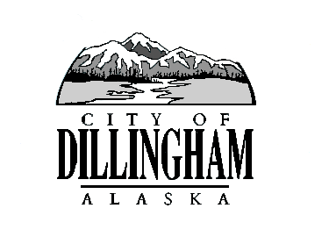
CITY OF

ALASKA
DILLINGHAM

HMAM

DILLINGHAM CITY COUNCIL

David B. Carlson Council Chambers
Dillingham City Hall, 141 Main Street, Dillingham, AK 99576 (907) 842-5212
REGULAR MEETING | 7:00 P.M. | FEBRUARY 1, 2018

1. CALL TO ORDER

2. ROLL CALL

3. APPROVAL OF MINUTES

- Regular Council Meeting, January 4, 2018 page 3

4. APPROVAL OF CONSENT AGENDA

APPROVAL OF AGENDA

5. STAFF REPORTS

- City Manager and Staff Reports page 7

- Standing Committee Reports (minutes in packet) page 39

6. PUBLIC HEARINGS

a. Ordinance No. 2017-10 (SUB1), An Ordinance of the Dillingham City Council Amending Municipal Code Title 4 – Revenue and Finance by the Addition of a New Chapter 4.24 Imposing an Excise Tax on Cigarettes and Tobacco Products page 47

7. CITIZEN’S DISCUSSION (Prior Notice or Agenda Items)

a. JD Palin and Bob Kallstrom; $5,000 Sales Tax Cap

8. ORDINANCES AND RESOLUTIONS

a. Adopt Ordinance No. 2017-10 (SUB1), An Ordinance of the Dillingham City Council Amending Municipal Code Title 4 – Revenue and Finance by the Addition of a New Chapter 4.24 Imposing an Excise Tax on Cigarettes and Tobacco Products page 47

b. Introduce Ordinance No. 2018-01, An Ordinance of the Dillingham City Council Amending Title 4.15.200 Foreclosure List, Timeframe to Present the Foreclosure List to Council page 61

- Adopt Resolution 2018-02, A Resolution of the Dillingham City Council Adopting the State of Alaska Local Government Model General Administrative Records Retention Schedule page 63

- Adopt Resolution 2018-03, A Resolution of the Dillingham City Council Expressing Support for Preferred Routes for a Manokotak – Dillingham Road page 73

9. UNFINISHED BUSINESS

a. Citizen Committee Appointments
1) Senior Advisory Commission, 1 Seat Open page 75

b. Progress Report

1) Dave Carlson House Property

2) Territorial School

10. NEW BUSINESS

11. CITIZEN’S DISCUSSION (Open to the Public)

12. COUNCIL COMMENTS

13. MAYOR’S COMMENTS

14. ADJOURNMENT

