Alice Ruby, Mayor

Council Members
• Tracy Hightower (Seat A) • Chris Maines (Seat B) • Aksel Buholm (Seat C)
• Curt Armstrong (Seat D) • Andy Anderson (Seat E) • Paul Liedberg (Seat F)
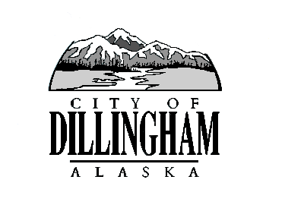
CITY OF

ALASKA
DILLINGHAM

HMAM

DILLINGHAM CITY COUNCIL

David B. Carlson Council Chambers
Dillingham City Hall, 141 Main Street, Dillingham, AK 99576 (907) 842-5212
WORKSHOP - REVIEW 9/30/2017 FINANCIAL STATEMENT | 6:30 P.M. | JANUARY 4, 2018
REGULAR MEETING | 7:00 P.M. | JANUARY 4, 2018

1. CALL TO ORDER

2. ROLL CALL

3. APPROVAL OF MINUTES

- Regular Council Meeting, December 7, 2017 page 3

4. APPROVAL OF CONSENT AGENDA

APPROVAL OF AGENDA

5. STAFF REPORTS

- City Manager and Staff Reports page 9

- Standing Committee Reports (minutes in packet) page 37

6. PUBLIC HEARINGS

a. Ordinance No. 2017-09, An Ordinance of the Dillingham City Council Amending Chapter 2.12.050 to Modify Posting Time of Adopted Ordinances page 43

7. CITIZEN’S DISCUSSION (Prior Notice or Agenda Items)

a. Tiffany Webb, Smoking Cessation

8. ORDINANCES AND RESOLUTIONS

a. Adopt Ordinance No. 2017-09, An Ordinance of the Dillingham City Council Amending Chapter 2.12.050 to Modify Posting Time of Adopted Ordinances
page 43

9. UNFINISHED BUSINESS

a. Ordinance No. 2017-10 (SUB1), An Ordinance of the Dillingham City Council Establishing a Tobacco Excise Tax page 45

b. Citizen Committee Appointments
1) Planning Commission, 2 Seats Open page 59

2) Senior Advisory Commission, 1 Seat Open

c. Progress Report

1) Dave Carlson House Property

2) Territorial School

10. NEW BUSINESS

a. Dillingham Liquor Store License Renewal page 61

b. February Council Training page 73

11. CITIZEN’S DISCUSSION (Open to the Public)

12. COUNCIL COMMENTS

13. MAYOR’S COMMENTS

14. EXECUTIVE SESSION

a. Legal Matter – Public Safety Update

15. ADJOURNMENT

