Alice Ruby, Mayor

Council Members
• Tracy Hightower (Seat A) • Chris Maines (Seat B) • Aksel Buholm (Seat C)
• Curt Armstrong (Seat D) • Andy Anderson (Seat E) • Paul Liedberg (Seat F)
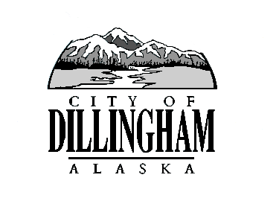
CITY OF

ALASKA
DILLINGHAM

HMAM

DILLINGHAM CITY COUNCIL

David B. Carlson Council Chambers
Dillingham City Hall, 141 Main Street, Dillingham, AK 99576 (907) 842-5212
SPECIAL MEETING | 12:15 P.M. | NOVEMBER 7, 2017

1. CALL TO ORDER

2. ROLL CALL

3. APPROVAL OF AGENDA

4. CITIZEN’S DISCUSSION (Prior Notice or Agenda Items)

5. SPECIAL BUSINESS

a. Adopt Resolution No. 2017-46; A Resolution of the Dillingham Council Approving the 2018-2023 Capital Improvement Plan and the FY2019 Legislative Priorities List page 3

b. Adopt Resolution No. 2017-47; A Resolution of the Dillingham Council Appointing an Alternate Community Representative to the BBEDC Board of Directors page 5

c. Action Memorandum No. 2017-17, Authorize the City Manager to enter into a contract with JJC Enterprises for Construction of the Landfill Cell 3 Expansion, Phase 1A page 7

d. Standing Committee Appointments page 17

6. CITIZEN’S DISCUSSION (Open to the Public)

7. COUNCIL COMMENTS

8. MAYOR’S COMMENTS

9. ADJOURNMENT

