Alice Ruby, Mayor

Council Members
• Tracy Hightower (Seat A) • Chris Maines (Seat B) • Misty Savo (Seat C)
• Curt Armstrong (Seat D) • Andy Anderson (Seat E) • Paul Liedberg (Seat F)
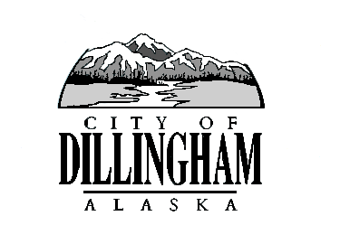
CITY OF

ALASKA
DILLINGHAM

HMAM

DILLINGHAM CITY COUNCIL

David B. Carlson Council Chambers
Dillingham City Hall, 141 Main Street, Dillingham, AK 99576 (907) 842-5212
TOUR OF NEW AMBULANCE | 6:15 P.M. | SEPTEMBER 7, 2017
WORKSHOP FOR REVIEW OF JUNE FINANCIAL STATEMENTS | 6:30 P.M. | SEPTEMBER 7, 2017
REGULAR MEETING | 7:00 P.M. | SEPTEMBER 7, 2017

1. CALL TO ORDER

2. ROLL CALL

3. APPROVAL OF MINUTES

- Regular Council Meeting, August 3, 2017 page

4. APPROVAL OF CONSENT AGENDA

APPROVAL OF AGENDA

5. STAFF REPORTS

- City Manager and Staff Reports page

- Standing Committee Reports page

6. PUBLIC HEARINGS

7. CITIZEN’S DISCUSSION (Prior Notice or Agenda Items)

- Gina Carpenter, Emergency Preparedness Mock Disaster Drill

8. ORDINANCES AND RESOLUTIONS

- Introduce Ordinance No. 2017-07, An Ordinance of the Dillingham City Council Amending Chapter 4.20 to Add an Exemption from Taxation on Real Property
page

b. Introduce Ordinance No. 2017-08, An Ordinance of the Dillingham City Council Amending Chapter 4.20 Sales Tax, Section 4.20.050 Exemptions page

c. Resolution No. 2017-34, A Resolution of the Dillingham City Authorizing the City Attorney to Investigate and File Suit Against John and Cindy Libby for Unpaid Sales Tax page

d. Resolution No. 2017-35, A Resolution of the Dillingham City Supporting a Long Term Encroachment Permit for the Properties Being Developed by the Bristol Bay Housing Authority at both Dave McClure and Cedar Subdivisions page

e. Resolution No. 2017-36, A Resolution of the Dillingham Council Waiving the Purchase Restrictions and Authorizing the City Manager to Award a Contract to CRW Engineering Group LLC to Design an Aeration System for the Lagoon page

9. UNFINISHED BUSINESS

a. Citizen Committee Appointments
1) Planning Commission, 2 Seats Open page

2) Senior Advisory Commission, 2 Seat Open page

3) Library Advisory Board, 4 Seats Open page

- Progress Report – Territorial School

- Progress Report – Carlson House Property

10. NEW BUSINESS

a. Action Memorandum No. 2017-15, Award a Contract to Bristol Alliance Fuels for FY18 Fuel Purchases page

11. CITIZEN’S DISCUSSION (Open to the Public)

12. COUNCIL COMMENTS

13. MAYOR’S COMMENTS

14. EXECUTIVE SESSION

a. Knik Construction Co. vs. Board of Equalization, City of Dillingham

15. ADJOURNMENT

