Alice Ruby, Mayor

Council Members
• Tracy Hightower (Seat A) • Chris Maines (Seat B) • Misty Savo (Seat C)
• Curt Armstrong (Seat D) • Andy Anderson (Seat E) • Paul Liedberg (Seat F)
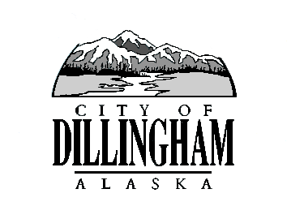
CITY OF

ALASKA
DILLINGHAM

HMAM

DILLINGHAM CITY COUNCIL

MEETING AGENDA

David B. Carlson Council Chambers
Dillingham City Hall, 141 Main Street, Dillingham, AK 99576 (907) 842-5212
REGULAR MEETING | 7:00 P.M. | AUGUST 3, 2017

1. CALL TO ORDER

2. ROLL CALL

3. APPROVAL OF MINUTES

a. Special Council Meeting July 13, 2017 page 5

4. APPROVAL OF CONSENT AGENDA

APPROVAL OF AGENDA

5. STAFF REPORTS

- City Manager Report page

- Standing Committee Reports (Clerk Note: No committee meetings were held.)

6. PUBLIC HEARINGS

7. CITIZEN’S DISCUSSION (Prior Notice or Agenda Items)

8. ORDINANCES AND RESOLUTIONS

- Resolution No. 2017-34, A Resolution of the Dillingham City Council Authorizing the City Attorney to Investigate and File Suit Against Jack and Cindy Libby d/b/a/ Dillingham Construction Co. for Unpaid Sales Tax page

9. UNFINISHED BUSINESS

a. Citizen Committee Appointments

- Senior Advisory Commission, 2 Seat Open
- Planning Commission, 2 Seats Open

- Library Advisory Board, 1 Seats Open

- Update – City Manager Hire

10. NEW BUSINESS

- Action Memorandum No. 2017-13, Award a Contract for the Harbor Float Design page

11. CITIZEN’S DISCUSSION (Open to the Public)

12. COUNCIL COMMENTS

13. MAYOR’S COMMENTS

14. EXECUTIVE SESSION

- Legal Matter - Update from Public Safety Department

15. ADJOURNMENT

