Alice Ruby, Mayor

Council Members
• Tracy Hightower (Seat A) • Chris Maines (Seat B) • Misty Savo (Seat C)
• Curt Armstrong (Seat D) • Andy Anderson (Seat E) • Paul Liedberg (Seat F)
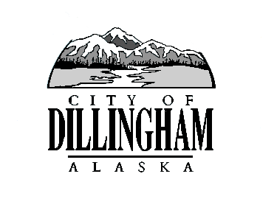
CITY OF

ALASKA
DILLINGHAM

HMAM

DILLINGHAM CITY COUNCIL

MEETING AGENDA

David B. Carlson Council Chambers
Dillingham City Hall, 141 Main Street, Dillingham, AK 99576 (907) 842-5212
SPECIAL MEETING | 12:15 P.M. | JULY 13, 2017

1. CALL TO ORDER

2. ROLL CALL

3. APPROVAL OF MINUTES

a. Regular Council Meeting, June 15, 2017 page 5

4. APPROVAL OF AGENDA

5. CITIZEN’S DISCUSSION (Prior Notice or Agenda Items)

6. PUBLIC HEARING

a. Adopt Ordinance No. 2017-06, An Ordinance of the Dillingham City Council Authorizing the Disposal of Municipal Property to the State of Alaska for the Dillingham Downtown Streets Rehabilitation Project page

7. SPECIAL BUSINESS

a. Adopt Ordinance No. 2017-06, An Ordinance of the Dillingham City Council Authorizing the Disposal of Municipal Property to the State of Alaska for the Dillingham Downtown Streets Rehabilitation Project page

b. Introduce Ordinance No. 2017-07, An Ordinance of the Dillingham City Council Amending Chapter 4.20 to Add an Exemption from Taxation on Real Property
page

c. Action Memorandum to Award a Contract for Harbor Float Design page

d. Action Memorandum to Award a Contract for Construction of Landfill Cell#3, Phase #1 page

e. Action Memorandum to Award a Contract for Sewer Lagoon and Dock Lift Station Improvements page

8. CITIZEN’S DISCUSSION (Open to the Public)

9. COUNCIL COMMENTS

10. MAYOR’S COMMENTS

11. EXECUTIVE SESSION

- Personnel Matter – City Manager Recruitment

12. ADJOURNMENT

