Alice Ruby, Mayor

Council Members
• Tracy Hightower (Seat A) • Chris Maines (Seat B) • Misty Savo (Seat C)
• Curt Armstrong (Seat D) • Andy Anderson (Seat E) • Paul Liedberg (Seat F)
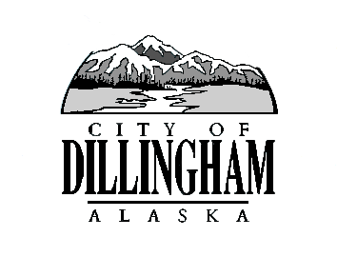
CITY OF

ALASKA
DILLINGHAM

HMAM

DILLINGHAM CITY COUNCIL

MEETING AGENDA –MARCH 2, 2017

David B. Carlson Council Chambers
Dillingham City Hall, 141 Main Street, Dillingham, AK 99576 (907) 842-5212
WORKSHOP – Quarterly Review of the Financial Statements | 6:30 P.M. | MARCH 2, 2017
REGULAR MEETING | 7:00 P.M. | MARCH 2, 2017

1. CALL TO ORDER

2. ROLL CALL

3. APPROVAL OF MINUTES

a. Regular Council Meeting, February 2, 2017 page

4. APPROVAL OF CONSENT AGENDA

APPROVAL OF AGENDA

5. STAFF REPORTS

- City Manager and Staff Reports page 13

- Standing Committee Reports page 45

6. PUBLIC HEARINGS

a. Adopt Ordinance No. 2017-01, An Ordinance of the Dillingham City Council Amending Dillingham Municipal Code Section 4.15.030 Property Exemptions, Senior Citizen and Disabled Veterans, to Add PFD Residency Requirement
page

b. Adopt Ordinance No. 2017-02, An Ordinance of the Dillingham City Council Amending Title 8 – Health and Safety by the Addition of a New Chapter Providing a Process for Reviewing Liquor License Applications page

7. CITIZEN’S DISCUSSION (Prior Notice or Agenda Items)

8. ORDINANCES AND RESOLUTIONS

a. Adopt Ordinance No. 2017-01, An Ordinance of the Dillingham City Council Amending Dillingham Municipal Code Section 4.15.030 Property Exemptions, Senior Citizen and Disabled Veterans, to Add PFD Residency Requirement
page

b. Adopt Ordinance No. 2017-02, An Ordinance of the Dillingham City Council Amending Title 8 – Health and Safety by the Addition of a New Chapter Providing a Process for Reviewing Liquor License Applications page

c. Introduce Ordinance No. 217-03, An Ordinance of the Dillingham City Council Amending Dillingham Municipal Code to Add Two New Offenses, To Add a Fine for Two Existing Offenses, and to Replace the Language for an Existing Offense
page

d. Adopt Resolution No. 2017-06, A Resolution of the Dillingham City Council

9. UNFINISHED BUSINESS

a. Citizen Committee Appointments
1) Senior Advisory Commission, 1 Seat Open
2) Territorial School Committee, 1 Seat Open

b. Annexation Update

c. Interim Task Force Borough Feasibility Study Update

10. NEW BUSINESS

a. Approve Action Memorandum No. 2017-04, page

11. CITIZEN’S DISCUSSION (Open to the Public)

12. COUNCIL COMMENTS

13. MAYOR’S COMMENTS

14. EXECUTIVE SESSION

a. Legal Matter – Dillingham & Manokotak Annexation Petitions

15. ADJOURNMENT

