Alice Ruby, Mayor

Council Members
• Tracy Hightower (Seat A) • Chris Maines (Seat B) • Misty Savo (Seat C)
• Curt Armstrong (Seat D) • Andy Anderson (Seat E) • Paul Liedberg (Seat F)
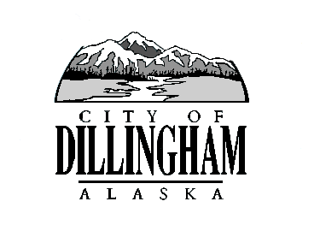
CITY OF

ALASKA
DILLINGHAM

HMAM

DILLINGHAM CITY COUNCIL

David B. Carlson Council Chambers
Dillingham City Hall, 141 Main Street, Dillingham, AK 99576 (907) 842-5212
SPECIAL MEETING | 12:00 P.M. | JANUARY 16, 2017

1. CALL TO ORDER

2. ROLL CALL

3. APPROVAL OF AGENDA

4. CITIZEN’S DISCUSSION (Prior Notice or Agenda Items)

5. SPECIAL BUSINESS

a. Executive Session – Personnel Matter

1) Manager Recruitment

6. CITIZEN’S DISCUSSION (Open to the Public)

7. COUNCIL COMMENTS

8. MAYOR’S COMMENTS

9. ADJOURNMENT

