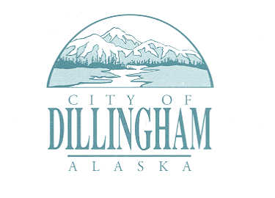
PUBLIC ANNOUNCEMENT

The City of Dillingham has extended public nominations for Capital Improvement Projects.
Nominations are due by 5:00 p.m. January 24, 2025.

FORMS AVAILABLE
ONLINE: https://www.dillinghamak.us/planning/page/public-notice-public-nominations-capital-improvement-projects
or
EMAIL: planner@dillinghamak.us

And at the Dillingham Public Library

Physical copies can be mailed to:
City of Dillingham
Box 889,
Dillingham, AK 99576

